Date:

To
The Earth Society
House # 147, Road # 01, Baridhara DOHS, Dhaka

Subject: Financial Proposal for supply & Delivery Office and Training Furniture under the EARN Project

Specification | Delivery Location | Sample Picture | UoM | Unit | Unit Price | Total Amount
Desk  Application: Workstation -4 Siter  Dimension: Length 96'', Depth 48'', Height 30'', Top Partition Board Height 12''  Top: 25 mm Water resistant Strong laminated board.  Others: 16 mm Water resistant Strong laminated board.  Edging: 1 mm PVC Edging.  Drawer Lock: Yes | Pabna: Chatmohar-1, Pabna Sadar-1, Santhia-1, Sujanagar-1  Mymensingh: Trishal-1, Kalmakanda-1, Kendua-1, Netrokuna Sadar-1, Purbadhola-1  Rangamati: Barkal & Belaichhari -1, Kawkhali-1, Kaptai-1  Bagerhat: Morelganj-1  Khulna: Dumuria-1, Dighalia-1, Rupsa-1  Narail: Lohagara-1,  Sathkhira: Sathkhira Sadar-1, Shyamnagar-1, Tala-1 | 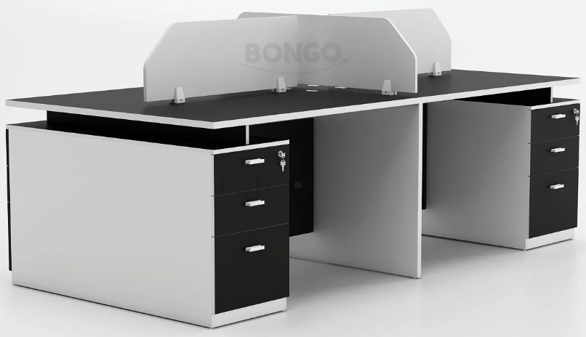 | Each | 20
Urban Visitor Chair:  Body: Made of best quality fiber plastic frame with mash fabrics. Seat: Best Quality 18mm thick Gorjon Plywood. Seating Height 18 Inches. Foam:Made of best quality Semi Rubber Foam. Base: Made of SS chrome based. | Pabna: Chatmohar-4, Pabna Sadar-4, Santhia-4, Sujanagar-4  Mymensingh: Trishal-4, Kalmakanda-4, Kendua-4, Netrokuna Sadar-4, Purbadhola-4  Rangamati: Barkal & Belaichhari -4, Kawkhali-4, Kaptai-4  Bagerhat: Morelganj-4  Khulna: Dumuria-4, Dighalia-4, Rupsa-4  Narail: Lohagara-4,  Sathkhira: Sathkhira Sadar-4, Shyamnagar-4, Tala-4 | 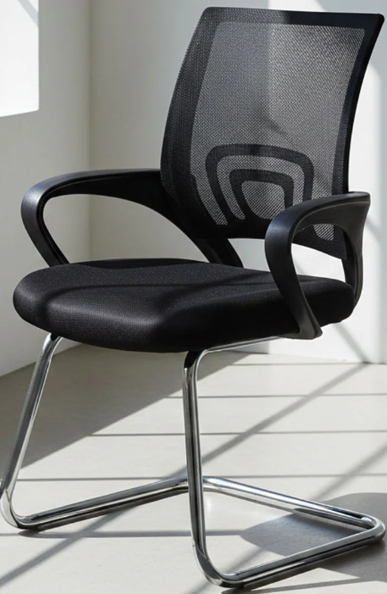 | Each | 80
Plastic Chair W/O Arm (Stick), Material: PP, Dimension CM: 52 X 37 X78, Attractive design, High-quality product | Pabna: Chatmohar-3, Pabna Sadar-3, Santhia-3, Sujanagar-3  Mymensingh: Trishal-3, Kalmakanda-3, Kendua-3, Netrokuna Sadar-3, Purbadhola-3  Rangamati: Barkal-3, Kawkhali-3, Belaichhari-0, Kaptai-3  Bagerhat: Morelganj-3  Khulna: Dumuria-3, Dighalia-3, Rupsa-3  Narail: Lohagara-3,  Sathkhira: Sathkhira Sadar-3, Shyamnagar-3, Tala-3 | 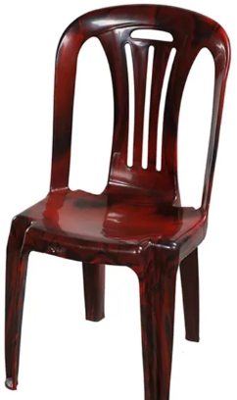 | Each | 60
Table and Chair Set for Trainers  Table Dimension: Length- 24"Depth - 18", Height- 30"  Chair Dimension: Length- 18",Depth - 16",Seating Height - 16", Height- 30"  Table Top:: 16 mm Laminated board  Others Place:16 mm Laminated board.  Board Edging:1mm edging.  Frame: Made of mighty mild steel  Metal Paint: Powder coating heat paint. | Pabna: Chatmohar-12, Pabna Sadar-12, Santhia-12, Sujanagar-9  Mymensingh: Trishal-6, Kalmakanda-3, Kendua-6, Netrokuna Sadar-9, Purbadhola-6  Rangamati: Barkal & Belaichhari-3, Kawkhali-3, , Kaptai-3  Bagerhat: Morelganj-12  Khulna: Dumuria-9, Dighalia-6, Rupsa-6  Narail: Lohagara-9,  Sathkhira: Sathkhira Sadar-12, Shyamnagar-6, Tala-6 | 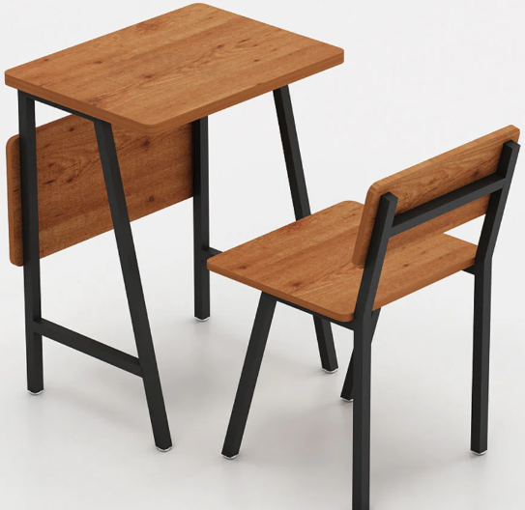 | Set | 150
Classroom Chair  Material: PP, Metal Frame-MS  Dimension (LxWxH): 71x46x80 cm  Attractive design  High-quality product  Durable product  Origin: Bangladesh | Pabna: Chatmohar-360, Pabna Sadar-360, Santhia-360, Sujanagar-270  Mymensingh: Trishal-180, Kalmakanda-90, Kendua-180, Netrokuna Sadar-270, Purbadhola-180  Rangamati: Barkal & Belaichhari-90, Kawkhali-90, Kaptai-90  Bagerhat: Morelganj-360  Khulna: Dumuria-270, Dighalia-180, Rupsa-180  Narail: Lohagara-270,  Sathkhira: Sathkhira Sadar-360, Shyamnagar-180, Tala-180 | 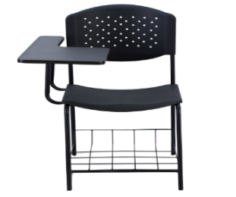 | Each | 4500
White Board  Deli EV900 Wall Mounted White Board 90 x 120 x 1.5 cm | Pabna: Chatmohar-12, Pabna Sadar-12, Santhia-12, Sujanagar-9  Mymensingh: Trishal-6, Kalmakanda-3, Kendua-6, Netrokuna Sadar-9, Purbadhola-6  Rangamati: Barkal & Belaichhari -3, Kawkhali-3, Kaptai-3  Bagerhat: Morelganj-12  Khulna: Dumuria-9, Dighalia-6, Rupsa-6  Narail: Lohagara-9,  Sathkhira: Sathkhira Sadar-12, Shyamnagar-6, Tala-6 | 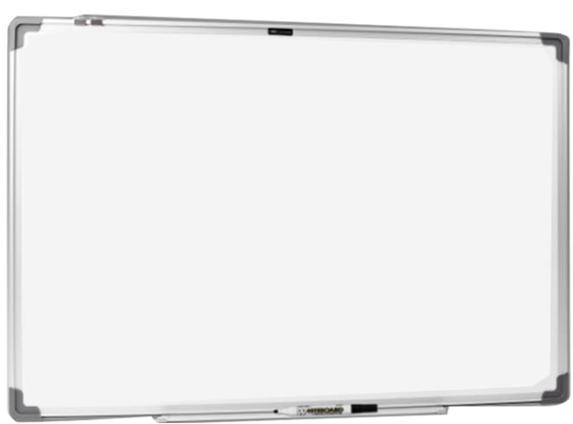 | Each | 150
Delivery and loading/unloading | Pabna: Chatmohar, Pabna Sadar, Santhia, Sujanagar  Mymensingh: Trishal, Kalmakanda, Kendua, Netrokuna Sadar, Purbadhola  Rangamati: Barkal & Belaichhari, Kawkhali, Kaptai  Bagerhat: Morelganj  Khulna: Dumuria, Dighalia, Rupsa  Narail: Lohagara,  Sathkhira: Sathkhira Sadar, Shyamnagar, Tala
Total:

Amount in words:

